# حيدورانت - haidurant

## What is "حيدورانت – haidurant"?

**# Source**: **Chatgpt (GPT-5-Standard) at [8/27/2025]**

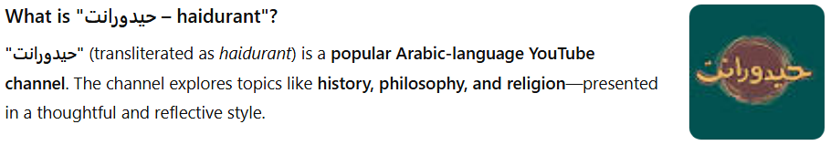

**"حيدورانت"** (transliterated as *haidurant*) is a **popular Arabic-language YouTube channel**. The channel explores topics like **history, philosophy, and religion**—presented in a thoughtful and reflective style.

## Key Highlights:

**# Source**: **Chatgpt (GPT-5-Standard) at [8/27/2025]**

* The channel’s content includes videos such as *"هل فعلاً التاريخ يكتبه المنتصر؟ وهل انتهت الفلسفة في عصرنا الحديث؟"* ("Does History Really Get Written by the Victors? And Has Philosophy Ended in Our Modern Era?") ([YouTube](https://www.youtube.com/%40-haidurant391?utm_source=chatgpt.com)).
* It also features titles like *"هل تتعارض الفلسفة مع الدين؟"* ("Does Philosophy Conflict with Religion?") ([YouTube](https://www.youtube.com/watch?v=Ko6zShaog4g&utm_source=chatgpt.com)).
* According to vidIQ, the channel has accumulated approximately **353,000 subscribers** and **15.35 million total views** as of August 2025 ([vidIQ](https://vidiq.com/youtube-stats/channel/UC1-Eg1iWNmDE_V953oOgh-Q/?utm_source=chatgpt.com" \o "حيدورانت - haidurant YouTube Channel Stats - vidIQ)).

## Summary Table

**# Source**: **Chatgpt (GPT-5-Standard) at [8/27/2025]**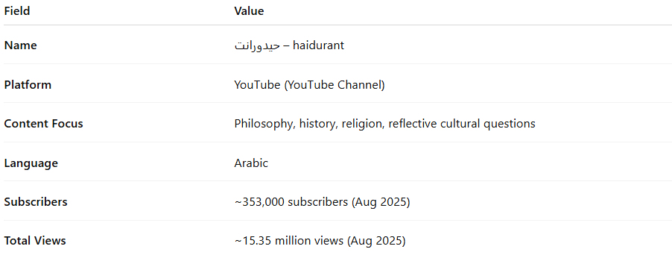

| **Field** | **Value** |
| --- | --- |
| **Name** | حيدورانت – haidurant |
| **Platform** | YouTube (YouTube Channel) |
| **Content Focus** | Philosophy, history, religion, reflective cultural questions |
| **Language** | Arabic |
| **Subscribers** | ~353,000 subscribers (Aug 2025) |
| **Total Views** | ~15.35 million views (Aug 2025) |